Insert School Logo

Semester Two

Examination 2018

Question/Answer booklet

MATHEMATICS
SPECIALIST UNITS 1 & 2

Section Two:
Calculator-assumed

Student Name: _____________________________________

Teacher’s Name: _____________________________________

Time allowed for this section
Reading time before commencing work: ten minutes
Working time for paper: one hundred minutes

Material required/recommended for this section

To be provided by the supervisor
This Question/Answer booklet
Formula Sheet (retained from Section One)

To be provided by the candidate
Standard items: pens (blue/black preferred), pencils (including coloured), sharpener, correction tape/fluid, erasers, ruler, highlighters

Special Items: drawing instruments, templates, notes on two unfolded sheets of A4 paper, and up to three calculators approved for use in the WACE examinations.

Important note to candidates
No other items may be taken into the examination room. It is your responsibility to ensure that you do not have any unauthorised notes or other items of a non-personal nature in the examination room. If you have any unauthorised material with you, hand it to the supervisor before reading any further.

Structure of this paper

 | Number of questions available | Number of questions to be attempted | Working time (minutes) | Marks available | Percentage of exam
Section One  Calculator—free | 7 | 7 | 50 | 50 | 35
Section Two  Calculator—assumed | 11 | 11 | 100 | 100 | 65
 |  |  |  |  | 100

Instructions to candidates

- The rules for the conduct of Western Australian external examinations are detailed in the
Year 12 Information Handbook 2016. Sitting this examination implies that you agree to abide by these rules.

- Answer the questions according to the following instructions.

Show all your working clearly. Your working should be in sufficient detail to allow your
answers to be checked readily and for marks to be awarded for reasoning. Incorrect answers given without supporting reasoning cannot be allocated any marks. For any question or part question worth more than two marks, valid working or justification is required to receive full marks. If you repeat an answer to any question, ensure that you cancel the answer you do not wish to have marked.

It is recommended that you do not use pencil, except in diagrams.

- You must be careful to confine your responses to the specific questions asked and to follow any instructions that are specific to a particular question.

- Spare pages are included at the end of this booklet. They can be used for planning your responses and/or as additional space if required to continue an answer.
- Planning: If you use the spare pages for planning, indicate this clearly at the top of the page.
- Continuing an answer: If you need to use the space to continue an answer, indicate in the original answer space where the answer is continued, i.e. give the page number. Fill in the number of the question that you are continuing to answer at the top of the page.

- The Formula Sheet is not handed in with your Question/Answer Booklet.

Section Two: Calculator–assumed 65% (100 marks)

This section has eleven (11) questions. Attempt all questions. Write your answers in the spaces
provided.

Working time: 100 minutes

Question 8 (5 marks)

(a) Fully factorise the complex polynomial $P\left(z\right)=2z^{2}-4z+3$. Show working for full marks.

(2 marks)

(b) $z=-1$ and $z=2+i$ are two solutions of the complex polynomial $R\left(z\right)=z^{3}+az^{2}+bz+c$,
where $a, b, c∈R$. State the third solution of $R\left(z\right)$ and determine the real constants $a,b$ and $c$.

(3 marks)

Question 9 (8 marks)

Prove the identity below for when $\cos{2θ}≠0$. (8 marks)

$$\tan\left(θ+\frac{π}{4}\right)=\frac{1+\sin{2θ}}{\cos{2θ}}$$

Question 10 (8 marks)

(a) Consider vectors $a=3i+j$, $b=i-3j$ and $c=αi-2j$, with $α∈R$.
Determine the value(s) of $α$ if:

(i) $a$ and $c$ are parallel. (2 marks)

(ii) $a+c$ is perpendicular to $b$. (2 marks)

(b) Find the projection vector of $m=i+5j$ onto $n=6i+4j$ using exact values.
Show ALL working for full marks. (4 marks)

Question 11 (10 marks)

Consider the series below for $n∈N, n>1:$

$$S_{n}=\frac{1}{2!}+\frac{2}{3!}+\frac{3}{4!}+\frac{4}{5!}+\frac{5}{6!}+…+\frac{n-1}{n!}$$

(a) Evaluate this expression for $n= 3$ and $4$. (2 marks)

(b) Evaluate the expression $\frac{n!-1}{n!}$ for $n= 3$ and $4$. (2 marks)

(c) Hence, write a conjecture about the value of this sequence in terms of $n$. (1 mark)

Question 11 (Continued)

(d) Use mathematical induction to prove your conjecture in (c). (5 marks)

Question 12 (11 marks)

Sydney is 878 km from Melbourne on a bearing of 048°T. Qantas flight QF438 flies directly from Melbourne to Sydney every day and their Boeing 737 can fly in still air at a cruising speed of 870 kmh⁻¹.

On a particular day, the flight encounters a wind of 80 kmh⁻¹ coming from the south-east. To counteract the effects of the wind and fly directly to Sydney the pilots must set the plane to fly on a bearing of $θ°$T.
Let the plane, wind and resultant vectors be represented by $p, w$ and $r$ respectively.

(a) Use the axes below to draw a diagram of the situation. (3 marks)

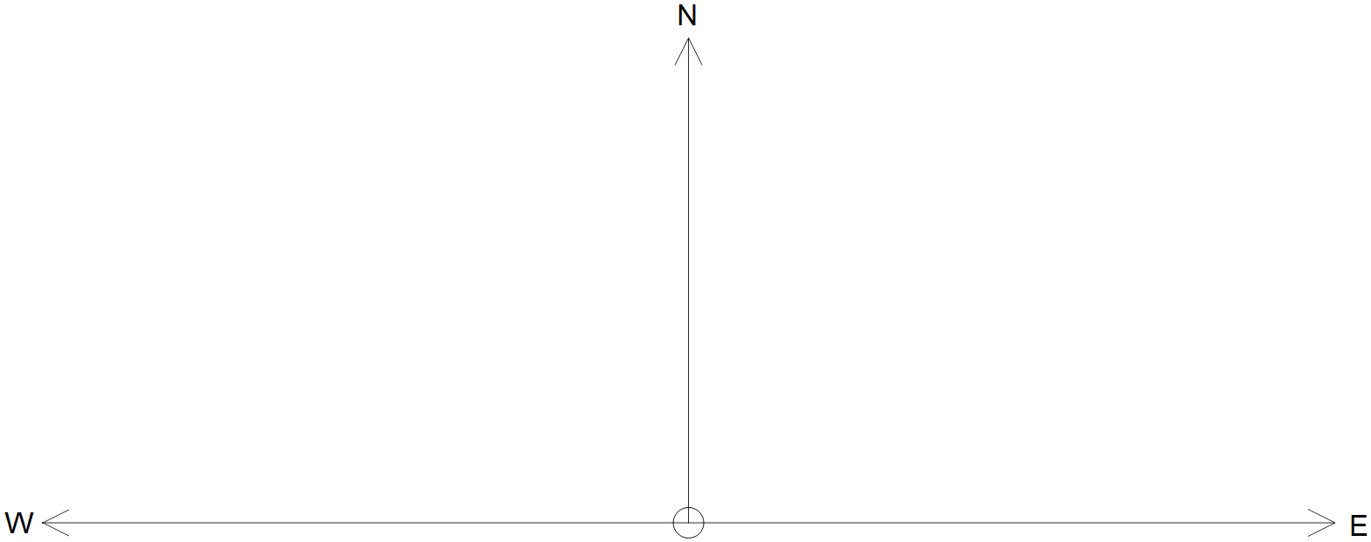

(b) Write $p, w$ and $r$ as position vectors in terms the information given and $θ$ as needed. (3 marks)

Question 12 (Continued)

(c) Use the fact that $p+w=r$ and your answers from (b) to find the bearing $θ°$T that the
pilots should set to counteract the effects of the wind. (3 marks)

(d) Assuming that the same wind is present for the entire duration of the flight, determine the time taken for the plane to travel from Melbourne to Sydney, correct to the nearest minute.
(2 marks)

Question 13 (6 marks)

(a) If $PQ-P=Q+I$ where $I=\left[\begin{matrix}1 & 0 \\ 0 & 1\end{matrix}\right]$ and $Q=\left[\begin{matrix}1 & 3 \\ -2 & 1\end{matrix}\right]$, find matrix $P$. (3 marks)

(b) Given that $A^{2}=3A-2I$, determine $A^{4}$ in terms of $A$ and $I$. (3 marks)

Question 14 (6 marks)

Consider the function $f\left(x\right)=\cos\left(2x\right)-\sqrt{3}\sin\left(2x\right)$ for the domain $0°≤x≤360°$.

(a) Express $f(x)$ as single sinusoid of the format $f\left(x\right)=R\cos\left(2x+θ\right)$, where $θ$ is acute. (4 marks)

(b) Hence, or otherwise, solve the equation $f\left(x\right)+1=0$ in the given domain. (2 marks)

Question 15 (8 marks)

(a) Consider the matrix $P=\left[ \begin{matrix}k+1 & 2 \\ 1 & k \end{matrix}\right]$ where $k$ is a real constant.

(i) If $P\left[\begin{matrix}2 & 1 \\ 0 & 2\end{matrix}\right]=\left[\begin{matrix}-2 & 3 \\ 2 & -3\end{matrix}\right]$ then solve for $k$. (2 marks)

(ii) Determine a condition on the value(s) of $k$ for which $P^{-1}$ exists. (2 marks)

Question 15 (Continued)

(b) Matrix $M$ is such that $M^{2}=I$, i.e. $M$ is an involution, where $M^{-1}=M$.
Given that $n∈N$, determine each of the following in terms of $M, M^{-1},I$ and/or $n$.

(i) $M^{2n+1}$ (1 mark)

(ii) $M^{-2n}$ (1 mark)

(c) Consider the matrix $A=\left[\begin{matrix}1 & 0 \\ 1 & 2\end{matrix}\right]$. Use your CAS calculator to observe the elements
of $A^{n}$ to make a conjecture about $A^{n}$ in terms of $n$. (2 marks)

Question 16 (12 marks)

Restaurants hire part-time and casual staff based on the volume of customers expected during the day.
Lunch (12pm) and dinner (7pm) are the most popular times and the predicted number of customers at a popular Italian restaurant varies between 180 people at peak times and 20 people at the low times.
The number of customers is modelled by a sinusoidal function $C(t)$, where $C$ is given as tens of customers and $t$ given as hours of the day.

(a) Sketch the graph of $C(t)$ on the grid below for the domain $8.5≤t≤22.5$. (3 marks)

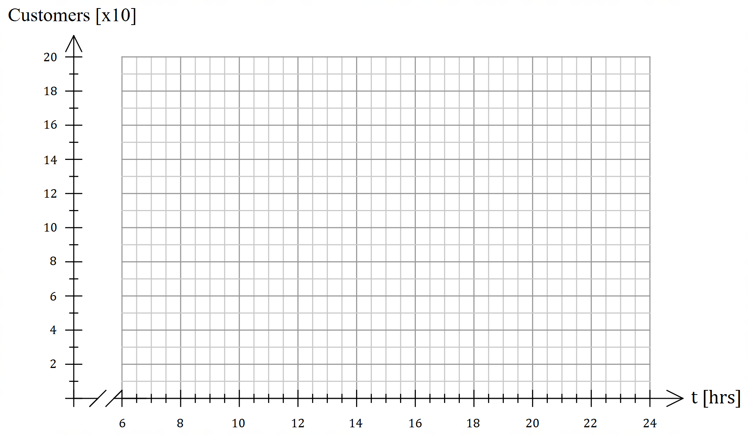

(b) If $C\left(t\right)=A\cos\left(ωt+ϕ\right)+v$, state the value of the constants $A, ω, ϕ$ and $v$. (4 marks)

Question 16 (Continued)

(c) The restaurant hires additional staff once the predicted number of customers is more
than 140. Determine the time(s), to the nearest minute, when the restaurant should hire
additional staff. Show working for full marks.
(5 marks)

Question 17 (14 marks)

(a) Consider the complex number $z$ given in the Argand plane below.

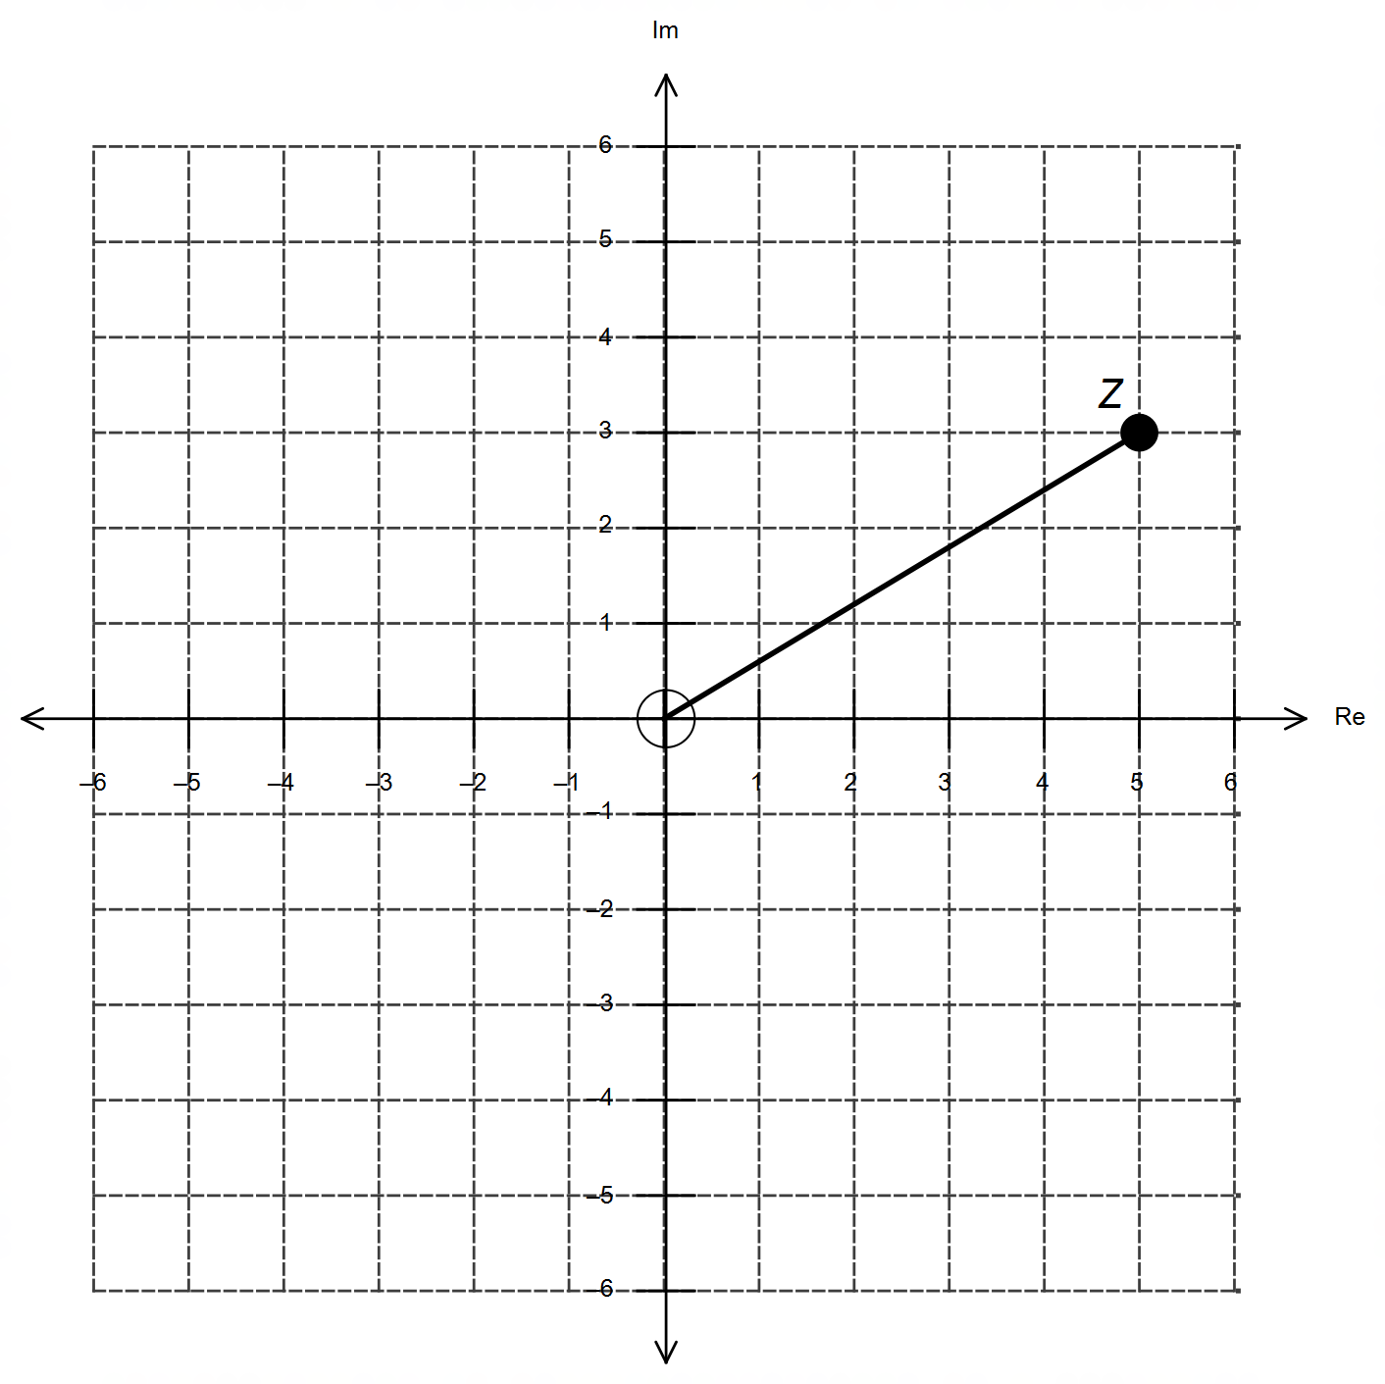

Sketch on the same diagram each of the following:

(i) $\overline{z}-i$ (2 marks)

(ii) $z-\overline{z}$ (2 marks)

(iii) $i\overline{z}$ (2 marks)

(iv) $\frac{z}{i}$ (2 marks)

Question 17 (Continued)

(b) Consider the complex number $z=\frac{1}{\sqrt{2}}\left(1+i\right)$ shown below.

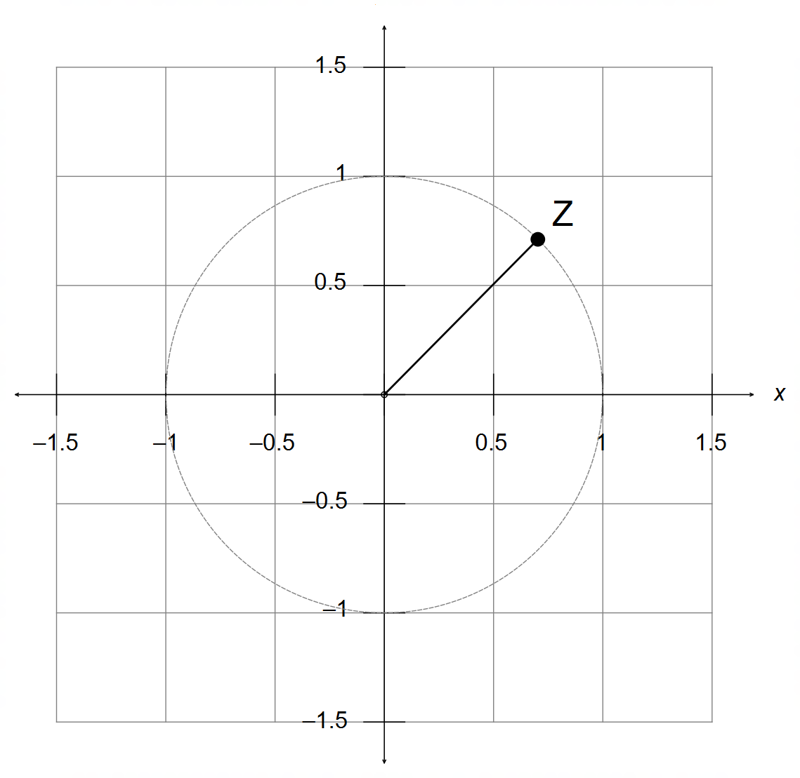

(i) Use your calculator to obtain $z^{2}, z^{3}$ and $z^{4}$ and plot these on the same grid above. (3 marks)

(ii) Describe the geometric effect observed when $z^{n}$ is multiplied by $z$ to obtain $z^{n+1}$. (2 marks)

(iii) Hence, deduce $z^{800}$. (1 mark)

Question 18 (12 marks)

Consider the matrix $T=\left[\begin{matrix}\cos{θ} & -\sin{ϕ} \\ \sin{θ} & \cos{ϕ}\end{matrix}\right]$, where both $θ$ and $ϕ$ are angles between $-180°$ and $180°$.

(a) A square matrix is said to be singular if it has no inverse.
Determine the relationship between $θ$ and $ϕ$ that make $T$ singular. (3 marks)

(b) Explain the geometric effect of $T$ as a transformation matrix when:

(i) $θ=90°$ and $ϕ=90°$. (2 marks)

(ii) $ϕ=-θ=90°$. (2 marks)

Question 18 (Continued)

(c) A square matrix is said to be an involution if it is its own inverse.
Determine the relationship between $θ$ and $ϕ$ that make $T$ an involution. (5 marks)

End of questions
Additional working space

Question number(s): ……………………

Additional working space

Question number(s): ……………………

Additional working space

Question number(s): ……………………

